**E-FARMER**

## A PROJECT REPORT

***Submitted by,***

**D SREE BHARGAV REDDY - 20201CSE0171**

**M ABHIRAM REDDY -20201CSE0116**

**KODIDALA BABU -20201CSE0170**

### *Under the guidance of,*

**Dr. RAGHAVENDRA M DEVADAS**

***in partial fulfillment for the award of the degree of***

**BACHELOR OF TECHNOLOGY**

**IN**

**COMPUTER SCIENCE AND ENGINEERING**

**At**



**PRESIDENCY UNIVERSITY**

**BENGALURU**

**JANUARY 2024**

**PRESIDENCY UNIVERSITY**

**SCHOOL OF COMPUTER SCIENCE AND ENGINEERING**

**CERTIFICATE**

This is to certify that the Project report **E-FARMER** being submitted by D SREE BHARGAV REDDY, M ABHIRAM REDDY,KODIDALA BABU bearing roll number(s) 20201CSE0171, 20201CSE0116, 20201CSE0170 in partial fulfilment of requirement for the award of degree of Bachelor of Technology in Computer Science and Engineering is a bonafide work carried out under my supervision.

|  |  |
| --- | --- |
| **Dr. RAGHAVENDRA M DEVADAS**  ASSISTANT PROFESSOR  School of CSE  Presidency University | **Dr. PALLAVI**  ASSOCIATE PROFESSOR & HoD  School of CSE  Presidency University |

|  |  |  |
| --- | --- | --- |
| **Dr. C. KALAIARASAN**  Associate Dean  School of CSE&IS  Presidency University | **Dr. L. SHAKKEERA**  Associate Dean  School of CSE&IS  Presidency University | **Dr. SAMEERUDDIN KHAN** Dean  School of CSE&IS  Presidency University |

**PRESIDENCY UNIVERSITY**

**SCHOOL OF COMPUTER SCIENCE AND ENGINEERING**

**DECLARATION**

We hereby declare that the work, which is being presented in the project report entitled **E-FARMER** in partial fulfilment for the award of Degree of **Bachelor of Technology** in **Computer Science and Engineering**, is a record of our own investigations carried under the guidance of **Dr. RAGHAVENDRA M DEVADAS,** **ASSISTANT PROFESSOR,** **School of Computer Science Engineering & Information Science, Presidency University, Bengaluru.**

We have not submitted the matter presented in this report anywhere for the award of any other Degree.

|  |  |  |  |  |  |  |  |  |  |  |  |  |  |  |  |
| --- | --- | --- | --- | --- | --- | --- | --- | --- | --- | --- | --- | --- | --- | --- | --- |
|  | |  |  |  |  |  |  |  |  |  |  |  |  |  |  | | --- | --- | --- | --- | --- | --- | --- | --- | --- | --- | --- | --- | --- | --- | | |  |  |  | | --- | --- | --- | | **Name of the Student’s** | **Roll Number’s** | **Signature of the Student’s** | | **D SREE BHARGAV REDDY** | **20201CSE0171** |  | | **M ABHIRAM REDDY** | **20201CSE0116** |  | | **KODIDALA BABU** | **20201CSE0170** |  | |  | |

**ABSTRACT**

The agriculture sector plays a crucial role in our country, but farmers often face challenges in selling their products directly without the involvement of middlemen. To address this issue, we have come up with a great idea that allows farmers to sell their products directly to customers at a fixed price, without any commissions charged by intermediaries. This is an e-commerce website that involves three types of roles: an admin who manages the website, farmers who sell and deliver the products, and users who place orders on the website.

**ACKNOWLEDGEMENT**

First of all, we indebted to the **GOD ALMIGHTY** for giving me an opportunity to excel in our efforts to complete this project on time.

We express our sincere thanks to our respected dean **Dr. Md. Sameeruddin Khan**, Dean, School of Computer Science Engineering & Information Science, Presidency University for getting us permission to undergo the project.

We record our heartfelt gratitude to our beloved Associate Deans **Dr. C Kalaiarasan and Dr. Shakkeera L,** School of Computer Science Engineering & Information Science, Presidency University and **Dr.** **PALLAVI**, **Head of the Department**, School of Computer Science Engineering & Information Science, Presidency University for rendering timely help for the successful completion of this project.

We are greatly indebted to our guide **Dr. RAGHAVENDRA M DEVADAS,** **Assistant Professor**, School of Computer Science Engineering & Information Science, Presidency University for his inspirational guidance, and valuable suggestions and for providing us a chance to express our technical capabilities in every respect for the completion of the project work.

We would like to convey our gratitude and heartfelt thanks to the University Project-II Coordinators **Dr. Sanjeev P Kaulgud, Dr. Mrutyunjaya MS** and also the department Project Coordinators **Mr. Zia Ur Rahman, Mr. Peniel John Whistely**.

We thank our family and friends for the strong support and inspiration they have provided us in bringing out this project.

**D SREE BHARGAV REDDY**

**M ABHIRAM REDDY**

**KODIDALA BABU**

**LIST OF TABLES**

|  |  |  |  |
| --- | --- | --- | --- |
| **Sl. No.** | **Table Name** | **Table Caption** | **Page No.** |
| 1 | Table 1 | Equipment Requirements | 12 |
| 2 | Table 2 | Technical Requirements | 12 |

**LIST OF FIGURES**

|  |  |  |  |  |  |  |
| --- | --- | --- | --- | --- | --- | --- |
| **Sl. No.** | **Figure Name** | | **Caption** | | **Page No.** | |
| 1 | Figure 1 | | Architecture Diagram | | 13 | |
| 2 | Figure 2 | | Chart of food shopping online | | 14 | |
| 3 | Figure 3 | | Sing In Page | | 43 | |
| 4 | Figure 4 | | Sing Up Page | | 43 | |
| 5 | Figure 5 | | Farmer’s Home page | | 44 | |
| 6 | Figure 6 | | Farmer’s Order page | | 44 | |
| 7 | Figure 7 | | Farmer’s Receipt page | | 45 | |
| 8 | Figure 8 | | Farmer’s Product list | | 45 | |
| 9 | Figure 9 | | User’s Home page | | 46 | |
| 10 | Figure 10 | | User’s Order page | | 46 | |
| 11 | Figure 11 | | Admin Page | | 47 | |
|  | |  | |  | |  | |
|  | |  | |  | |  | |

**TABLE OF CONTENTS**

|  |  |  |
| --- | --- | --- |
| **CHAPTER NO.** | **TITLE** | **PAGE NO.** |
|  | **ABSTRACT**  **ACKNOWLEDGMENT** | **iv**  **v** |
| **1.** | **INTRODUCTION** | **2** |
| **2.** | **LITERATURE REVIEW** |  |
|  | **2.1**Sri Lankan Agrarian Service Centre E-farmer Management  System | 4 |
|  | **2.2** Self Service for E-Farmers | 4 |
|  | **2.3** E-Farmer | 5 |
|  | **2.4** E-Farmer | 5 |
|  | **2.5** E-Farmer Management System to Empower Small-Scale Agriculture Producers in Sri Lanka | 6 |
|  | **2.6** E-commerce is facilitated through mobile applications, aiding farmers in selling their crops | 6 |
|  | **2.7** Voice-Enabled Help Desk: From Farmer to E-Farmer | 7 |
|  | **2.8** A Symbiotic Relationship Between Mobile Technology and Agriculture | 8 |
|  | **2.9** Agricultural E-commerce Future Trends: Making Way for e-Farmer | 8 |
| **3.** | **RESEARCH GAPS OF EXISTING METHODS** | 9 |
| **4.** | **PROPOSED MOTHODOLOGY** | 11 |
| **5.** | **OBJECTIVES** | 12 |
| **6.** | **SYSTEM DESIGN & IMPLEMENTATION** | 13 |
| **7.** | **TIMELINE FOR EXECUTION OF PROJECT** | 16 |
| **8.** | **OUTCOMES** | 17 |
| **9.** | **RESULTS AND DISCUSSIONS** | 18 |
| **10.** | **CONCLUSION** | 20 |
|  | **REFERENCES** | 21 |
|  | **PSUEDOCODE** | 22 |
|  | **SCREENSHOTS** | 44 |
|  | **ENCLOSURES** | 56 |

**CHAPTER-1**

**INTRODUCTION**

E-farmer is increasingly influencing the agricultural sector, prompting a heightened focus on the process of acquiring agricultural products. Currently, customers often face the inconvenience of having to travel considerable distances to obtain these products, with the added challenge of uncertain product quality. Despite the diligent efforts of farmers in production, the prevalence of unscrupulous agents in today's market results in significant losses for them. This project seeks to alleviate these challenges by facilitating direct transactions between farmers and customers through a computerized approach, thereby benefiting both parties in the buying and selling of agricultural products. The "E-commerce Website for Grocery Retail" project introduces a user-friendly online platform designed to revolutionize grocery shopping. Providing a diverse array of grocery products, the website prioritizes convenience through an intuitive interface, personalized user accounts, and advanced search features. Security is paramount, with robust payment gateways ensuring safe financial transactions and data privacy.

Efficiency is a key focus, with streamlined order processing, real-time inventory management, and reliable delivery options enhancing the overall customer experience. Embracing contemporary e-commerce trends, the platform boasts a responsive design, catering to users across various devices. This initiative aims to bridge the gap between traditional and modern grocery shopping, catering to the fast-paced lifestyles of today's consumers.

The project's vision extends beyond facilitating transactions, aiming to create a reliable, secure, and efficient digital space for users to meet their grocery needs. The integration of technology not only enhances the accessibility of the platform but also contributes to a seamless, end-to-end shopping experience. Ultimately, this e-commerce website seeks to redefine grocery retail by combining the convenience of online shopping with the reliability and diversity essential for a comprehensive grocery shopping experience.

These websites revolutionize the grocery shopping experience by offering consumers a convenient and efficient platform to purchase a wide array of groceries. With an intuitive user interface, these websites ensure easy navigation and quick access to a comprehensive catalog that includes fresh produce. The design prioritizes responsiveness across different devices, allowing customers to seamlessly browse and shop using smartphones or tablets.

**CHAPTER-2**

**LITERATURE SURVEY**

**2.1 Sri Lankan Agrarian Service Centre E-farmer Management System (2015)**

“The E-farmer Management System (EFMS) would be constructed with Web-based technologies and the C# programming language to give users integration and accessibility. The system employs a centralized database system, via which all clients can access the EFMS network.

This study used both quantitative and qualitative methods. Document reviews were utilized to uncover quantitative values. Interviews, observations, and case studies were employed to disclose qualitative values. EFMS is the greatest answer for farmers who are frustrated by the inefficiency and lack of communication of Sri Lanka's agrarian service centers. It will usher in a new era in Sri Lanka's agricultural economy.”

**Advantages:** Automation and technology simplify farming procedures, saving time and effort.

**Limitations:** Adoption of technology sometimes necessitates significant upfront investments, which can be difficult for smaller or resource-limited farms.

**2.2 Self Service for E-Farmers**

**(Tharani K, Varsini N, Revathi K, and Sri Karthick M)**

“The website acts as a complete reference for farmers, providing access to new agricultural practices and allowing for a comparison of current market pricing for various goods. It delivers insights into overall sales and earned earnings from sold items, offering a platform for direct contact among farmers, between farmers and agents, and with customers. This online platform boosts profitability by encouraging direct relationships. The website, which serves as a safe and unique medium for agro-marketing, allows visitors to explore a wide choice of items and make immediate purchases using online payment methods.”

**Advantages:** Real-time data assists in making informed decisions on weather, market trends, and best practices.

**Limitations:** Farmers' reliance on technology might be problematic if they do not have access to stable internet connectivity or energy.

**2.3 E-Farmer(D Novianti , Dewi Anjani 2020)**

“Software testing is a crucial phase in application development, where a poorly designed testing tool can potentially jeopardize the final software product. E-farmer, an Android-based application designed for farmers, enables the calculation of profit yield for each crop. The testing of E-farmer aims to assess the error rate within the program, with the ultimate goal of ensuring the application aligns with its intended functions and purposes. This testing employs the Black-box Testing technique in conjunction with the Boundary Value Analysis methodology. The results of the study indicate that the application achieves an 88.89% success rate across three distinct fields.”

**Advantages:** Online platforms connect farmers directly to customers, removing the need for middlemen.

**Limitations:** The collecting and storage of sensitive farm data raises privacy and abuse concerns.

**2.4 E-Farmer (D Novianti 2018)**

"This study aimed to assess the influence of the promotional mix on sales levels, specifically focusing on assisting farmers in selling their agricultural produce. The "E-Farmer for Android" e-commerce application is crafted to support farmers in marketing their produce and providing them with pertinent information. To test the hypothesis regarding the impact of this application on sales, farmers who utilized the app were surveyed, and basic regression analysis and F-tests were conducted. The findings revealed that the promotion of e-commerce applications through "E-Farmer for Android" had a positive effect on sales levels.”

**Advantages:** Efficient resource utilization, automation, and data-driven choices can all help to reduce operating expenses.

**Limitations:** Farmers may need to learn new skills to efficiently employ e-farming technology, which may be a hurdle for some.

**2.5 E-Farmer Management System to Empower Small-Scale Agriculture Producers in Sri Lanka (2020)**

“According to the Ministry of Rural Development, the major goals of Dedicated Economic Centers are to ensure farm producers earn appropriate prices for their goods by offering a targeted market and providing a chance for small-scale producers to reduce transportation costs and waste. Make it possible for wholesalers to buy Source fresh fruits and vegetables directly, and promote a competitive marketing environment.

Traders in bulk. Make it possible to supply area-specific agricultural products to consumers around the island, and make it possible for people to purchase food items at reduced costs. Marketing agricultural products differs from other types of marketing.”

**Advantages:** Online sales, agro-tourism, and value-added goods enable for revenue diversification through e-farming.

**Limitations:** Farmers may become unduly reliant on a few providers for technology, seeds, and other inputs.

**2.6 E-commerce is facilitated through mobile applications, aiding farmers in selling their crops (2023)**

“The agriculture sector plays a vital role in driving the Indonesian economy, and Village stands out as one of the key plant product producers in the Kertasari District. Unfortunately, many farmers encounter challenges, including surplus crops being sold at low prices, leading to financial losses, and complexities in distribution. These issues must be addressed to enhance the appreciation of Indonesian agricultural goods. To assist farmers, an Android-based application named "Petani Sejahtera" has been developed. This application holds the potential to revolutionize the agricultural commodity delivery system.

It has the potential to disrupt the agricultural commodity delivery system. You can contact the courier who has worked with the management by showing information on product pricing lists, farmers' products, and harvested items that will be distributed later during the major harvest time. So that farmers can see the items sown and not have to think about how to distribute the products afterward. The goal of developing this "Petani Sejahtera" Application is to assist farmers in more readily distributing their goods to numerous vendors, preventing harvest produce buildup.”

**Advantages:** Farmers may remotely monitor and control activities for flexibility and convenience.

**Limitations:** Inadequate infrastructure, such as bad roads or a lack of energy, may make it difficult to adopt e-farming technology effectively.

**2.7 Voice-Enabled Help Desk: From Farmer to E-Farmer**

Voice-enabled Information Desk to provide the most recent and up-to-date information to rural Indian farmers. The purpose of this article is to describe how the Information Desk may explain/guide/respond to aspects of government schemes and other information in the user's native/regional language. A user's voice command is used to interact with an Information Desk. Interaction between the user and the voice-enabled Information Desk that is friendly. The Information Desk will provide the customer guidance and ideas in the user's native language. The experimental accuracy and error rates were 89.58% and 10.42%.

**Advantages:** Data analysis may help estimate agricultural yields, market trends, and appropriate planting dates.

**Limitations:** Increased use of e-farming technology may lead to market saturation, thereby eroding early adopters' competitive edge.

**2.8 A Symbiotic Relationship Between Mobile Technology and Agriculture**

This literature review examines the influence of mobile interfaces on farmer adoption of e-commerce platforms, focusing on the symbiotic relationship between mobile technology and agricultural practices. It investigates worldwide trends in rural mobile technology usage, providing E-Farmer with strategic insights to enhance its platform for mobile accessibility and user engagement.

**Advantages:** Financial planning, budgeting, and credit access are aided by digital tools.

**Limitations:** The manufacturing and disposal of electronic equipment may contribute to contamination of the environment.

**2.9 Agricultural E-commerce Future Trends: Making Way for eFarmer**

Anticipating the future, this literature study investigates developing trends in agricultural e-commerce. By remaining ahead of the curve, eFarmer may present itself as an innovator, adjusting its techniques to meet evolving demands. The review examines technological advancements, consumer behaviors, and market dynamics, providing a glimpse into the future landscape of agricultural e-commerce.

**Advantages:** Online platforms allow farmers to engage in the global economy and reach out to global customers.

**Limitations:** An overreliance on technology may result in the extinction of traditional farming knowledge and practices.

**CHAPTER-3**

**RESEARCH GAPS OF EXISTING METHODS**

According to the Ministry of Rural Development, the major goals of Dedicated Economic Centers are to ensure farm producers earn appropriate prices for their goods by offering a targeted market and providing a chance for small-scale producers to reduce transportation costs and waste. Make it possible for wholesalers to buy Source fresh fruits and vegetables directly, and promote a competitive marketing environment.

Traders in bulk. Make it possible to supply area-specific agricultural products to consumers around the island, and make it possible for people to purchase food items at reduced costs. Marketing agricultural products differs from other types of marketing.”

The E-farmer Management System (EFMS) would be constructed with Web-based technologies and the C# programming language to give users integration and accessibility. The system employs a centralized database system, via which all clients can access the EFMS network.

This study used both quantitative and qualitative methods. Document reviews were utilized to uncover quantitative values. Interviews, observations, and case studies were employed to disclose qualitative values. EFMS is the greatest answer for farmers who are frustrated by the inefficiency and lack of communication of Sri Lanka's agrarian service centers. It will usher in a new era in Sri Lanka's agricultural economy.”

“The website acts as a complete reference for farmers, providing access to new agricultural practices and allowing for a comparison of current market pricing for various goods. It delivers insights into overall sales and earned earnings from sold items, offering a platform for direct contact among farmers, between farmers and agents, and with customers. This online platform boosts profitability by encouraging direct relationships. The website, which serves as a safe and unique medium for agro-marketing, allows visitors to explore a wide choice of items and make immediate purchases using online payment methods.

This study aimed to assess the influence of the promotional mix on sales levels, specifically focusing on assisting farmers in selling their agricultural produce. The "E-Farmer for Android" e-commerce application is crafted to support farmers in marketing their produce and providing them with pertinent information. To test the hypothesis regarding the impact of this application on sales, farmers who utilized the app were surveyed, and basic regression analysis and F-tests were conducted. The findings revealed that the promotion of e-commerce applications through "E-Farmer for Android" had a positive effect on sales levels

**CHAPTER-4**

**PROPOSED MOTHODOLOGY**

1. This E-Famers Website namely Farmer’s Mart for direct selling of products from Farmer to Customers.

2. The proposed methods for Farmer’s Mart include a user-centric design for an intuitive interface and streamlined navigation.

3. A comprehensive product curation system will manage a diverse range of groceries.

4. Efficient order processing will be achieved with real-time inventory tracking.

5. Data analytics will optimize inventory management for timely restocking.

6. Responsive customer support will address queries promptly. Continuous innovation and updates will ensure the platform remains competitive.

7. Sustainable practices, like eco-friendly packaging, will be explored.

8. Rigorous quality assurance testing will guarantee platform stability and reliability.

**CHAPTER-5**

**OBJECTIVES**

1. Redefine the traditional grocery shopping experience by introducing an innovative and efficient online platform that seamlessly integrates with modern consumer lifestyles.
2. Streamline order processing, inventory management, and delivery logistics to optimize operational efficiency, ensuring timely and reliable delivery of a diverse range of fresh grocery items.
3. Curate a comprehensive product range, from farm-fresh produce to pantry staples, catering to the diverse needs and preferences of consumers, and providing a one-stop solution for their grocery requirements.

**CHAPTER-6**

**SYSTEM DESIGN & IMPLEMENTATION**

**EQUIPMENT REQUIREMENTS**

This section contains information and specs on the hardware that will be used by the system.

|  |  |
| --- | --- |
| Processor Uesd | Intel Core |
| RAM | 4 GB DDR4 RAM |
| Monitor | 14, Color |
| ROM | 40 GB |
| Keyboard | Standard 102 keys |
| Mouse | Optical |

*Table 1: Equipment Requirement’s*

**TECHNICAL REQUIREMENTS FOR SOFTWARE**

This section gives the details of the software that is used for the development.

|  |  |
| --- | --- |
| Environment | eclipse |
| Front-End | Html, Css ,JS |
| Back-End | My SQL Server (Java) |
| Coding Language | Full Stack Web Development |
| Operating System | Windows 11 |
| Browser | Google Chrome |

Table 2 : Technical Requirements

**ARCHITECTURE DIAGRAM**

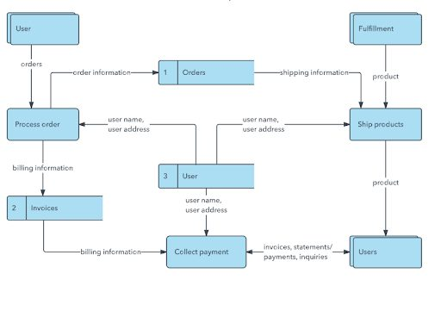

Figure 1: Architecture Diagram

**PAGE OF LOGIN & REGISTRATION**

The login function should be used to access system users. To log into the system, users should already have usernames and passwords.

Tour farmers who are new users can utilize the registration page to obtain access credentials.

**PAGE ADMINISTRATION**

Every principal user must create a user account and register with the system. The system will then automatically produce a user ID based on the user type.

An administrator can modify the rules of a new website user.

**PAGE OF THE FARMER**

And farmers get their products based on the items they sell and set the price based on the item based on the users that order from the website.

According to the farmer's end, they are the ordered page, receipt page, and product adding page, as illustrated below.

**PAGE FOR USERS**

Users are the clients who will order things from the Website at a lower cost straight from the Farmers.

What do you generally buy when you go food shopping online?

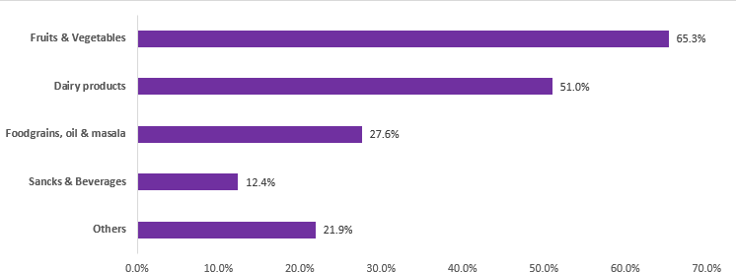

Figure 2: Chart of food shopping online

The creation of a complete digital platform that simplifies and improves numerous elements of agricultural activity is required for the design and implementation of an e-farmer system. This approach attempts to empower farmers by giving them with technical tools to efficiently manage their fields and make informed decisions.

During the design process, user interface design is carefully considered to ensure that the platform is user-friendly and accessible to farmers with varied degrees of technological expertise. Integration with mobile devices is frequently a critical component for ensuring widespread adoption. Security measures are also put in place to secure critical farm data and farmers' privacy.

The actual creation of the e-farmer system based on the design standards is referred to as implementation. Depending on the tastes and demands of the intended user population, this may entail developing a web-based application. The system should be scalable to meet farmers' rising demands, and it should have a solid backend architecture to manage data processing and storage.

**CHAPTER-7**

**TIMELINE FOR EXECUTION OF PROJECT**

**(GANTT CHART)**

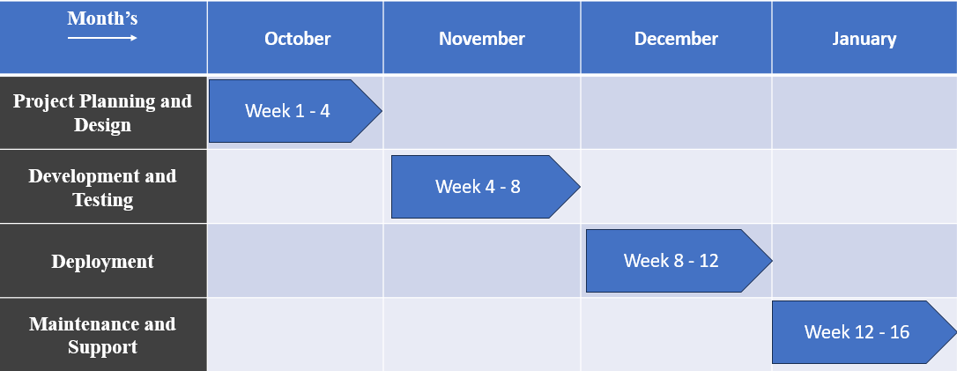

**CHAPTER-8**

**OUTCOMES**

1.) The Farmer's Mart project aims to provide an intuitive and secure online grocery buying platform, as well as to ease user navigation and protect data privacy.

2.) The end result is expected to be efficient order processing, real-time inventory tracking, and optimum inventory management for prompt replenishing.

3.) By emphasizing sustainability and quality assurance, the initiative seeks to provide a competitive and dependable alternative for consumers looking for different and environmentally responsible food options.

4.) The initiative aims to revolutionize the digital grocery retail sector by providing a reliable, responsive, and environmentally friendly platform.

5.) Increased the efficiency of the agricultural supply chain.

6.) Environmental Impact and Long-Term Practices.

**CHAPTER-9**

**RESULTS AND DISCUSSIONS**

**User Engagement and Website Traffic:**

• **Analysis of Traffic:**

* + 1. The total number of visitors, unique visitors, and pageviews.
    2. Traffic sources (organic, direct, referral, social).
    3. Visitors' geographical location.

**• User Engagement:**

* + 1. The average amount of time spent on the website.
    2. The bounce rates.
    3. The most popular sites and goods.

**• Sales Performance:**

* + 1. Total sales, conversion rates.
    2. Best-selling items.
    3. Order value on average.

• **Checkout Process:**

* + 1. Rates of abandonment.
    2. Customer feedback on the checkout process.
    3. Suggestions for improvement.

**Mobile Responsiveness:**

**• Mobile Traffic:**

* + 1. The percentage of people who access the site via mobile devices.
    2. Conversion rates for mobile devices.
    3. Any problems reported with mobile devices.

• **Responsive Design:**

Assessing the responsiveness of a website.

Suggestions for improvement.

**User Experience (UX):**

• **Navigation and Design:**

Evaluation of website layout and design.

Navigational ease.

* + 1. Feedback from users on their entire experience.

**• Loading Time:**

Page load times.

Speed optimization suggestions.

**• Response Time:**

The average response time to consumer questions.

Support channel options (chat, email, phone).

**• Customer Feedback and Complaints:**

Analyze customer feedback and complaints.

Actions made to resolve problems

**Marketing and Promotions:**

**• Marketing efforts:**

1. Analyze recent marketing efforts.
2. Marketing effort return on investment.

**• Promotions and Discounts:**

1. Promotional and discount effectiveness.

ii. Sales and consumer loyalty are affected.

**Privacy and security:**

• **Safety precautions:**

1. Overview of existing security mechanisms.
2. Any security incidents that have been reported.

**• Privacy Policy:**

1. Adherence to privacy rules.
2. Data collection and use transparency.

**CHAPTER-10**

**CONCLUSION**

Finally, the E-Farmer e-commerce website idea has enormous potential for changing the agricultural scene. E-Farmer aspires to empower farmers, improve their access to critical products, and contribute to the general growth of the agricultural sector by harnessing digital technology.

Farmer's Mart is ready to disrupt online grocery shopping by stressing user-centric design, a wide range of products, and strong security measures. The simpler method maintains the focus on quick order processing, real-time inventory management, and responsive customer support. Farmer's Mart aspires to revolutionize the digital grocery shopping experience by providing a trustworthy and environmentally conscious platform for modern consumers, with an unwavering dedication to innovation, sustainability, and quality assurance.

**REFERENCES**

Karunarathna, K. N. N. S., & Vidanagama, D. U. (2015). E-farmer Management System for Agrarian Service Centre in Sri Lanka.

**2.)** Tharani, K., Varsini, N., & Revathi, K. (2019). E-Farmer Self Service. *South Asian Journal of Engineering and Technology*, *8*(2), 203-204.

**3.)** Novianti, D., & Anjani, D. (2020). Pengujian Aplikasi E-FARMER dalam Perhitungan Keuntungan dengan Metode Blackbox Testing Boundary Value Analysis. *Jurnal Nasional Informatika (JUNIF)*, *1*(2), 77-81.

**4.)** Novianti, D. (2018). Pengaruh Bauran Promosi Terhadap Tingkat Penjualan Petani Pada Aplikasi E-commerce ‘E-farmer for Android'. *Rabit*, *3*(2), 60-68.

**5.)** Sandareka, K. P. P., Pradeep, R. M. M., Wedasinghe, N., & Perera, M. P. L. E-Farmer Management System for Empowering Sri Lankan Small-Scale Agriculture-Based Producers.

**6.)** Hafizh, M. A. A., & Wibowo, A. P. W. (2023). E-BUSINESS TO SUPPORT SALES OF FARMER CROPS BASED ON MOBILE APPLICATIONS. *Jurnal Darma Agung*, *31*(1), 18-31.

**APPENDIX-A**

**PSUEDOCODE**

**<HTML>**

**Home.html**

BEGIN

PRINT "<!DOCTYPE html>"

PRINT "<html lang='en' xmlns:th='http://www.thymeleaf.org'>"

PRINT "<th:block>"

PRINT " <div th:replace='fragments/head.html :: head'></div>"

PRINT "</th:block>"

PRINT "<body>"

PRINT "<th:block>"

PRINT " <div th:replace='fragments/header.html :: header'></div>"

PRINT "</th:block>"

PRINT "<main>"

PRINT " <h3 th:text='|${greeting}, ${#authentication.getPrincipal().getUsername()}!|' class='text-center brush-script'></h3>"

PRINT " <div>"

PRINT " <div class='row d-flex justify-content-between'>"

PRINT " <div class='data col-md'>"

PRINT " <h1 class='text-center brush-script font-weight-bold' id='categoryTittle' th:text='|All Products|'></h1>"

PRINT " <div id='searchBar' class='input-group w-25'>"

PRINT " <span class='input-group-btn'>"

PRINT " <button class='btn btn-secondary mr-1' onclick='findProductByProductName()'>"

PRINT " <i class='fas fa-search'></i> Find</button>"

PRINT " </span>"

PRINT " <input type='text' th:name='username'"

PRINT " class='form-control w-50' id='inputProductName'"

PRINT " placeholder='Product name...'/>"

PRINT " </div>"

PRINT " </div>"

PRINT " <div class='print-container container-fluid'>"

PRINT " <div class='row mb-4 d-flex justify-content-start products-data'>"

PRINT " </div>"

PRINT " </div>"

PRINT " </div>"

PRINT " </div>"

PRINT " <section class='p-4 md:p-8 lg:p-12'>"

PRINT " <h2 class='text-2xl md:text-3xl lg:text-4xl font-bold mb-4 md:mb-6'><b>Recommendations</b></h2>"

PRINT " <div class='grid grid-cols-1 md:grid-cols-2 lg:grid-cols-3 gap-4 md:gap-6'>"

PRINT " <div class='border bg-card text-card-foreground rounded-lg shadow-lg overflow-hidden' data-v0-t='card'>"

PRINT " <img"

PRINT " src='https://res.cloudinary.com/dzrlwqy7g/image/upload/v1703249083/x0z7eprxphvsjtozhhow.jpg'"

PRINT " alt='Recommendation 1'"

PRINT " class='w-full object-cover h-48'"

PRINT " width= 150;"

PRINT " height= 150;"

PRINT " style='aspect-ratio: 200 / 200; object-fit: cover;'"

PRINT " />"

PRINT " <div class='flex flex-col space-y-1.5 p-4'>"

PRINT " <h3 class='tracking-tight text-xl font-bold'>Carrots</h3>"

PRINT " <p class='text-sm text-gray-600'><b>Price:</b> ₹15.00</p> <p><b>New Price:</b> ₹11.25</p>"

PRINT " <span class='fa fa-star checked'></span>"

PRINT " <span class='fa fa-star checked'></span>"

PRINT " <span class='fa fa-star checked'></span>"

PRINT " <span class='fa fa-star'></span>"

PRINT " <span class='fa fa-star'></span>"

PRINT " </div>"

PRINT " </div>"

PRINT " <div class='border bg-card text-card-foreground rounded-lg shadow-lg overflow-hidden' data-v0-t='card'>"

PRINT " <img"

PRINT " src='https://res.cloudinary.com/dzrlwqy7g/image/upload/v1703235979/vhbjv8tbuv3g5kper8ze.jpg'"

PRINT " alt='Recommendation 2'"

PRINT " class='w-full object-cover h-48'"

PRINT " width=150;"

PRINT " height=150;"

PRINT " style='aspect-ratio: auto; object-fit: cover;'"

PRINT " />"

PRINT " <div class='flex flex-col space-y-1.5 p-4'>"

PRINT " <h3 class='tracking-tight text-xl font-bold'>sweet potato</h3>"

PRINT " <p class='text-sm text-gray-600'>This is the description for recommendation 3.</p>"

PRINT " <span class='fa fa-star checked'></span>"

PRINT " <span class='fa fa-star checked'></span>"

PRINT " <span class='fa fa-star checked'></span>"

PRINT " <span class='fa fa-star checked'></span>"

PRINT " <span class='fa fa-star'></span>"

PRINT " </div>"

PRINT " </div>"

PRINT " </div>"

PRINT " </section>"

PRINT "</main>"

PRINT "<th:block>"

PRINT " <div th:replace='fragments/footer.html :: footer'></div>"

PRINT "</th:block>"

PRINT "<script th:src='@{/js/home.js}'></script>"

PRINT "<script th:src='@{/js/product-search.js}'></script>"

PRINT "</body>"

PRINT "</html>"

END

**Index.html**

INCLUDE animate.css

INCLUDE head.html

BEGIN BODY

BEGIN CONTAINER-FLUID

INCLUDE header.html

BEGIN MAIN

BEGIN PARAGRAPH

BEGIN ANCHOR

SET HREF ATTRIBUTE TO "/register"

SET IMG ATTRIBUTES (BORDER, ALT, SRC)

END ANCHOR

END PARAGRAPH

BEGIN DIV

BEGIN ROW

BEGIN DATA COLUMN

BEGIN DIV

SET CLASS ATTRIBUTE TO "animated-sentences animate__animated animate__slideInLeft"

SET HEADING TEXT

BEGIN ANCHOR

SET HREF ATTRIBUTE TO "/login"

SET ANCHOR TEXT

END ANCHOR

BEGIN UNORDERED LIST

BEGIN LIST ITEM

BEGIN ANCHOR

SET HREF ATTRIBUTE TO "/login"

SET ANCHOR TEXT

END ANCHOR

END LIST ITEM

...

(Repeat for other list items)

...

END UNORDERED LIST

END DIV

END DATA COLUMN

BEGIN PRINT CONTAINER

BEGIN ROW

BEGIN PRODUCTS-DATA DIV

END ROW

END PRINT CONTAINER

END ROW

END DIV

END MAIN

INCLUDE footer.html

END CONTAINER-FLUID

END BODY

INCLUDE sales.js

END

**Login.html**

BEGIN

PRINT "<!DOCTYPE html>"

PRINT "<html lang="en" xmlns:th="http://www.thymeleaf.org">"

PRINT ""

PRINT "<th:block>"

PRINT " <div th:replace="fragments/head.html :: head"></div>"

PRINT "</th:block>"

PRINT ""

PRINT "<body>"

PRINT "<div class="container-fluid">"

PRINT ""

PRINT "<th:block>"

PRINT " <div th:replace="fragments/header.html :: header"></div>"

PRINT "</th:block>"

PRINT ""

PRINT "<main class="mt-5">"

PRINT " <div class="jumbotron bg-re-form w-25 m-auto">"

PRINT " <th:block th:if="${param.logout}">"

PRINT " <div class="text-center brush-script" style="color: #4fa36f">"

PRINT " Successful logout"

PRINT " </div>"

PRINT " </th:block>"

PRINT " <h2 class="text-center mc-colorize brush-script">Sing In</h2>"

PRINT ""

PRINT " <form th:action="@{/login}" th:method="POST">"

PRINT " <div class="form-group">"

PRINT " <label for="inputUsername" class="brush-script">Username</label>"

PRINT " <input type="text" class="form-control" id="inputUsername" name="username""

PRINT " placeholder="Enter username...">"

PRINT " </div>"

PRINT ""

PRINT " <div class="form-group">"

PRINT " <label for="inputPassword" class="brush-script">Password</label>"

PRINT " <input type="password" class="form-control" id="inputPassword" name="password""

PRINT " placeholder="Password...">"

PRINT " </div>"

PRINT ""

PRINT " <div class="form-group form-check">"

PRINT " <input type="checkbox" class="form-check-input" id="inputCheckRememberMe">"

PRINT " <label class="form-check-label brush-script" for="inputCheckRememberMe">Remember me</label>"

PRINT " </div>"

PRINT ""

PRINT " <button type="submit" class="btn w-100 bg-re"><i class="fas fa-sign-in-alt"></i>Login</button>"

PRINT " </form>"

PRINT " <th:block th:if="${param.error}">"

PRINT " <div class="text-center" style="color: red" th:text="${session.SPRING_SECURITY_LAST_EXCEPTION.message}">"

PRINT " <!--Bad Credentials-->"

PRINT " </div>"

PRINT " </th:block>"

PRINT ""

PRINT " </div>"

PRINT "</main>"

PRINT ""

PRINT "<th:block>"

PRINT " <div th:replace="fragments/footer.html :: footer"></div>"

PRINT "</th:block>"

PRINT ""

PRINT "</div>"

PRINT "</body>"

PRINT "</html>"

END

**<CSS>**

**Style.css**

BEGIN

PRINT "<!DOCTYPE html>"

PRINT "<html lang='en' xmlns:th='http://www.thymeleaf.org'>"

PRINT ""

PRINT "<th:block>"

PRINT " <div th:replace='fragments/head.html :: head'></div>"

PRINT "</th:block>"

PRINT ""

PRINT "<body>"

PRINT "<div class='container-fluid'>"

PRINT ""

PRINT " <th:block>"

PRINT " <div th:replace='fragments/header.html :: header'></div>"

PRINT " </th:block>"

PRINT ""

PRINT " <main class='mt-5'>"

PRINT " <div class='jumbotron bg-re-form w-25 m-auto'>"

PRINT " <h2 class='text-center brush-script mc-colorize'>Sing Up</h2>"

PRINT ""

PRINT " <form th:action='@{/register}' th:method='post' th:object='${model}'>"

PRINT " <div class='form-group' th:classappend='${#fields.hasErrors('username')}? 'text-danger'">"

PRINT " <label for='inputUsername' class='brush-script'>Username</label>"

PRINT " <input type='text' class='form-control' id='inputUsername' name='username' th:field='*{username}'"

PRINT " placeholder='Enter username...'>"

PRINT " <small id='usernameHelp' th:each='error : ${#fields.errors('username')}' th:text='${error}'>"

PRINT " Error Message"

PRINT " </small>"

PRINT " </div>"

PRINT ""

PRINT " <div class='form-group' th:classappend='${#fields.hasErrors('password')}? 'text-danger'">"

PRINT " <label for='inputPassword' class='brush-script'>Password</label>"

PRINT " <input type='password' class='form-control' id='inputPassword' name='password' th:field='*{password}'"

PRINT " placeholder='Password...'>"

PRINT " <small id='passwordHelp' th:each='error : ${#fields.errors('password')}' th:text='${error}'>"

PRINT " Error Message"

PRINT " </small>"

PRINT " </div>"

PRINT ""

PRINT " <div class='form-group' th:classappend='${#fields.hasErrors('confirmPassword')}? 'text-danger'">"

PRINT " <label for='inputConfirmPassword' class='brush-script'>Confirm Password</label>"

PRINT " <input type='password' class='form-control' id='inputConfirmPassword' name='confirmPassword' th:field='*{confirmPassword}'"

PRINT " placeholder='Confirm Password...'>"

PRINT " <small id='confirmPasswordHelp' th:each='error : ${#fields.errors('confirmPassword')}' th:text='${error}'>"

PRINT " Error Message"

PRINT " </small>"

PRINT " </div>"

PRINT ""

PRINT " <div class='form-group' th:classappend='${#fields.hasErrors('address')}? 'text-danger'">"

PRINT " <label for='inputShippingAddress' class='brush-script'>Shipping Address</label>"

PRINT " <input type='text' class='form-control' id='inputShippingAddress' name='address' th:field='*{address}'"

PRINT " placeholder='Shipping Address...'>"

PRINT " <small id='addresHelp' th:each='error : ${#fields.errors('address')}' th:text='${error}'>"

PRINT " Error Message"

PRINT " </small>"

PRINT " </div>"

PRINT ""

PRINT " <div class='form-group' th:classappend='${#fields.hasErrors('email')}? 'text-danger'">"

PRINT " <label for='inputEmail' class='brush-script'>Email address</label>"

PRINT " <input type='email' class='form-control' id='inputEmail' aria-describedby='emailHelp' name='email' th:field='*{email}'"

PRINT " placeholder='Enter email...'>"

PRINT " <small id='emailHelp' th:each='error : ${#fields.errors('email')}' th:text='${error}'>"

PRINT " Error Message"

PRINT " </small>"

PRINT " </div>"

PRINT " <button type='submit' class='btn w-100 bg-re'><i class='fas fa-user-plus'></i>Register</button>"

PRINT " </form>"

PRINT ""

PRINT " </div>"

PRINT " </main>"

PRINT ""

PRINT " <th:block>"

PRINT " <div th:replace='fragments/footer.html :: footer'></div>"

PRINT " </th:block>"

PRINT ""

PRINT "</div>"

PRINT ""

PRINT "<script>"

PRINT " function htmlEscape(input) {"

PRINT " input.replace(/&/g, '&amp;')"

PRINT " .replace(/</g, '&lt;')"

PRINT " .replace(/>/g, '&gt;')"

PRINT " .replace(/'/g, '&quot;');"

PRINT " }"

PRINT "</script>"

PRINT ""

PRINT "</body>"

PRINT "</html>"

END

**Profile.html**

BEGIN

PRINT "<!DOCTYPE html>"

PRINT "<html lang='en' xmlns:th='http://www.thymeleaf.org' xmlns:sec='http://www.thymeleaf.org/thymeleaf-extras-springsecurity4'>"

PRINT "<th:block>"

PRINT " <div th:replace='fragments/head.html :: head'></div>"

PRINT "</th:block>"

PRINT ""

PRINT "<body>"

PRINT "<th:block>"

PRINT " <div th:replace='fragments/header.html :: header'></div>"

PRINT "</th:block>"

PRINT ""

PRINT "<main class='mt-4 mb-4'>"

PRINT " <div class='jumbotron mt-3 bg-re text-center w-50 m-auto'>"

PRINT " <figure>"

PRINT " <img src='https://thevoicefinder.com/wp-content/themes/the-voice-finder/images/default-img.png' alt='' class='img-circle' style='width:75px;' id='user-img'>"

PRINT " </figure>"

PRINT " <h3 class='text-white d-inline-block mr-2'>Username: </h3>"

PRINT " <h3 class='d-inline-block' th:text='${viewModel.username}'></h3>"

PRINT " <hr class='hr-2' color='white'/>"

PRINT " <div class='row'>"

PRINT " <div class='col-md-6'>"

PRINT " <h5 class='text-white'>Email:</h5>"

PRINT " </div>"

PRINT " <div class='col-md-6'>"

PRINT " <h5 th:text='${viewModel.email}'></h5>"

PRINT " </div>"

PRINT " </div>"

PRINT " <hr class='hr-2' color='white'/>"

PRINT " <div class='row'>"

PRINT " <div class='col-md-6'>"

PRINT " <h5 class='text-white'>Shipping Address:</h5>"

PRINT " </div>"

PRINT " <div class='col-md-6'>"

PRINT " <h5 th:text='${viewModel.address}'></h5>"

PRINT " </div>"

PRINT " </div>"

PRINT " <hr class='hr-2' color='white'/>"

PRINT " <div class='row'>"

PRINT " <div class='col-md-6'>"

PRINT " <h5>Authorities:</h5>"

PRINT " </div>"

PRINT " <div class='col-md-6'>"

PRINT " <h6 th:each='role : ${viewModel.authorities}' th:text='${role.authority}'>Item description here...</h6>"

PRINT " </div>"

PRINT " </div>"

PRINT ""

PRINT " <th:block sec:authorize='hasRole('ROLE_ADMIN')'>"

PRINT " <hr class='hr-2' color='white'/>"

PRINT " <div class='row'>"

PRINT " <div class='col-md-4'>"

PRINT " <h5 class='text-white'>Set Authorities:</h5>"

PRINT " </div>"

PRINT " <div class='col-md-8'>"

PRINT " <form th:action='@{/users/edit/role/{id}(id=${viewModel.id})}' method='post'>"

PRINT " <div class='custom-control custom-radio d-inline-block'>"

PRINT " <input class='custom-control-input' type='radio' name='role' th:id='roleUser' th:value='ROLE_USER'>"

PRINT " <label class='custom-control-label' th:for='roleUser' th:text='User'></label>"

PRINT " </div>"

PRINT " <div class='custom-control custom-radio d-inline-block ml-2'>"

PRINT " <input class='custom-control-input' type='radio' name='role' th:id='roleModerator' th:value='ROLE_MODERATOR'>"

PRINT " <label class='custom-control-label' th:for='roleModerator' th:text='Moderator'></label>"

PRINT " </div>"

PRINT " <div class='custom-control custom-radio d-inline-block ml-2'>"

PRINT " <input class='custom-control-input' type='radio' name='role' th:id='roleAdmin' th:value='ROLE_ADMIN'>"

PRINT " <label class='custom-control-label' th:for='roleAdmin' th:text='Admin'></label>"

PRINT " </div>"

PRINT " <button id='submitButton' class='btn btn-success ml-3' style='background-color: #7abaff' th:text='Update'></button>"

PRINT " </form>"

PRINT " </div>"

PRINT " </div>"

PRINT " </th:block>"

PRINT " </div>"

PRINT "</main>"

PRINT ""

PRINT "<th:block>"

PRINT " <div th:replace='fragments/footer.html :: footer'></div>"

PRINT "</th:block>"

PRINT ""

PRINT "</body>"

PRINT "</html>"

END

**Registration.html**

BEGIN

PRINT "<!DOCTYPE html>"

PRINT "<html lang='en' xmlns:th='http://www.thymeleaf.org'>"

PRINT ""

PRINT "<th:block>"

PRINT " <div th:replace='fragments/head.html :: head'></div>"

PRINT "</th:block>"

PRINT ""

PRINT "<body>"

PRINT "<div class='container-fluid'>"

PRINT ""

PRINT "<th:block>"

PRINT " <div th:replace='fragments/header.html :: header'></div>"

PRINT "</th:block>"

PRINT ""

PRINT "<main class='mt-5'>"

PRINT " <div class='jumbotron bg-re-form w-25 m-auto'>"

PRINT " <h2 class='text-center brush-script mc-colorize'>Sing Up</h2>"

PRINT ""

PRINT " <form th:action='@{/register}' th:method='post' th:object='${model}'>"

PRINT " <div class='form-group' th:classappend='${#fields.hasErrors('username')}? 'text-danger''>"

PRINT " <label for='inputUsername' class='brush-script'>Username</label>"

PRINT " <input type='text' class='form-control' id='inputUsername' name='username' th:field='*{username}'"

PRINT " placeholder='Enter username...'>"

PRINT " <small id='usernameHelp' th:each='error : ${#fields.errors('username')}' th:text='${error}'>"

PRINT " Error Message"

PRINT " </small>"

PRINT " </div>"

PRINT ""

PRINT " <div class='form-group' th:classappend='${#fields.hasErrors('password')}? 'text-danger''>"

PRINT " <label for='inputPassword' class='brush-script'>Password</label>"

PRINT " <input type='password' class='form-control' id='inputPassword' name='password' th:field='*{password}'"

PRINT " placeholder='Password...'>"

PRINT " <small id='passwordHelp' th:each='error : ${#fields.errors('password')}' th:text='${error}'>"

PRINT " Error Message"

PRINT " </small>"

PRINT " </div>"

PRINT ""

PRINT " <div class='form-group' th:classappend='${#fields.hasErrors('confirmPassword')}? 'text-danger''>"

PRINT " <label for='inputConfirmPassword' class='brush-script'>Confirm Password</label>"

PRINT " <input type='password' class='form-control' id='inputConfirmPassword' name='confirmPassword' th:field='*{confirmPassword}'"

PRINT " placeholder='Confirm Password...'>"

PRINT " <small id='confirmPasswordHelp' th:each='error : ${#fields.errors('confirmPassword')}' th:text='${error}'>"

PRINT " Error Message"

PRINT " </small>"

PRINT " </div>"

PRINT ""

PRINT " <div class='form-group' th:classappend='${#fields.hasErrors('address')}? 'text-danger''>"

PRINT " <label for='inputShippingAddress' class='brush-script'>Shipping Address</label>"

PRINT " <input type='text' class='form-control' id='inputShippingAddress' name='address' th:field='*{address}'"

PRINT " placeholder='Shipping Address...'>"

PRINT " <small id='addresHelp' th:each='error : ${#fields.errors('address')}' th:text='${error}'>"

PRINT " Error Message"

PRINT " </small>"

PRINT " </div>"

PRINT ""

PRINT " <div class='form-group' th:classappend='${#fields.hasErrors('email')}? 'text-danger''>"

PRINT " <label for='inputEmail' class='brush-script'>Email address</label>"

PRINT " <input type='email' class='form-control' id='inputEmail' aria-describedby='emailHelp' name='email' th:field='*{email}'"

PRINT " placeholder='Enter email...'>"

PRINT " <small id='emailHelp' th:each='error : ${#fields.errors('email')}' th:text='${error}'>"

PRINT " Error Message"

PRINT " </small>"

PRINT " </div>"

PRINT " <button type='submit' class='btn w-100 bg-re'><i class='fas fa-user-plus'></i>Register</button>"

PRINT " </form>"

PRINT ""

PRINT " </div>"

PRINT "</main>"

PRINT ""

PRINT "<th:block>"

PRINT " <div th:replace='fragments/footer.html :: footer'></div>"

PRINT "</th:block>"

PRINT ""

PRINT "</div>"

PRINT ""

PRINT "<script>"

PRINT " function htmlEscape(input) {"

PRINT " input.replace(/&/g, '&amp;')"

PRINT " .replace(/</g, '&lt;')"

PRINT " .replace(/>/g, '&gt;')"

PRINT " .replace(/'/g, '&quot;');"

PRINT " }"

PRINT "</script>"

PRINT ""

PRINT "</body>"

PRINT "</html>"

END

**Add-Product.html**

BEGIN HTML

BEGIN HEAD

// Head content

END HEAD

BEGIN BODY

BEGIN HEADER

// Header content

END HEADER

BEGIN MAIN

BEGIN JUMBOTRON

PRINT "Add Product"

BEGIN FORM

SET action to "/products/add"

SET method to "post"

SET enctype to "multipart/form-data"

BEGIN INPUT

SET type to "hidden"

SET name to "_csrf"

SET value to "c686cd14-a7f9-4216-8009-c093b7d3df86"

END INPUT

BEGIN PRODUCT-FORM

// Include product form content

END PRODUCT-FORM

END FORM

END JUMBOTRON

END MAIN

BEGIN FOOTER

// Footer content

END FOOTER

END BODY

END HTML

**APPENDIX-B**

**SCREENSHOTS**

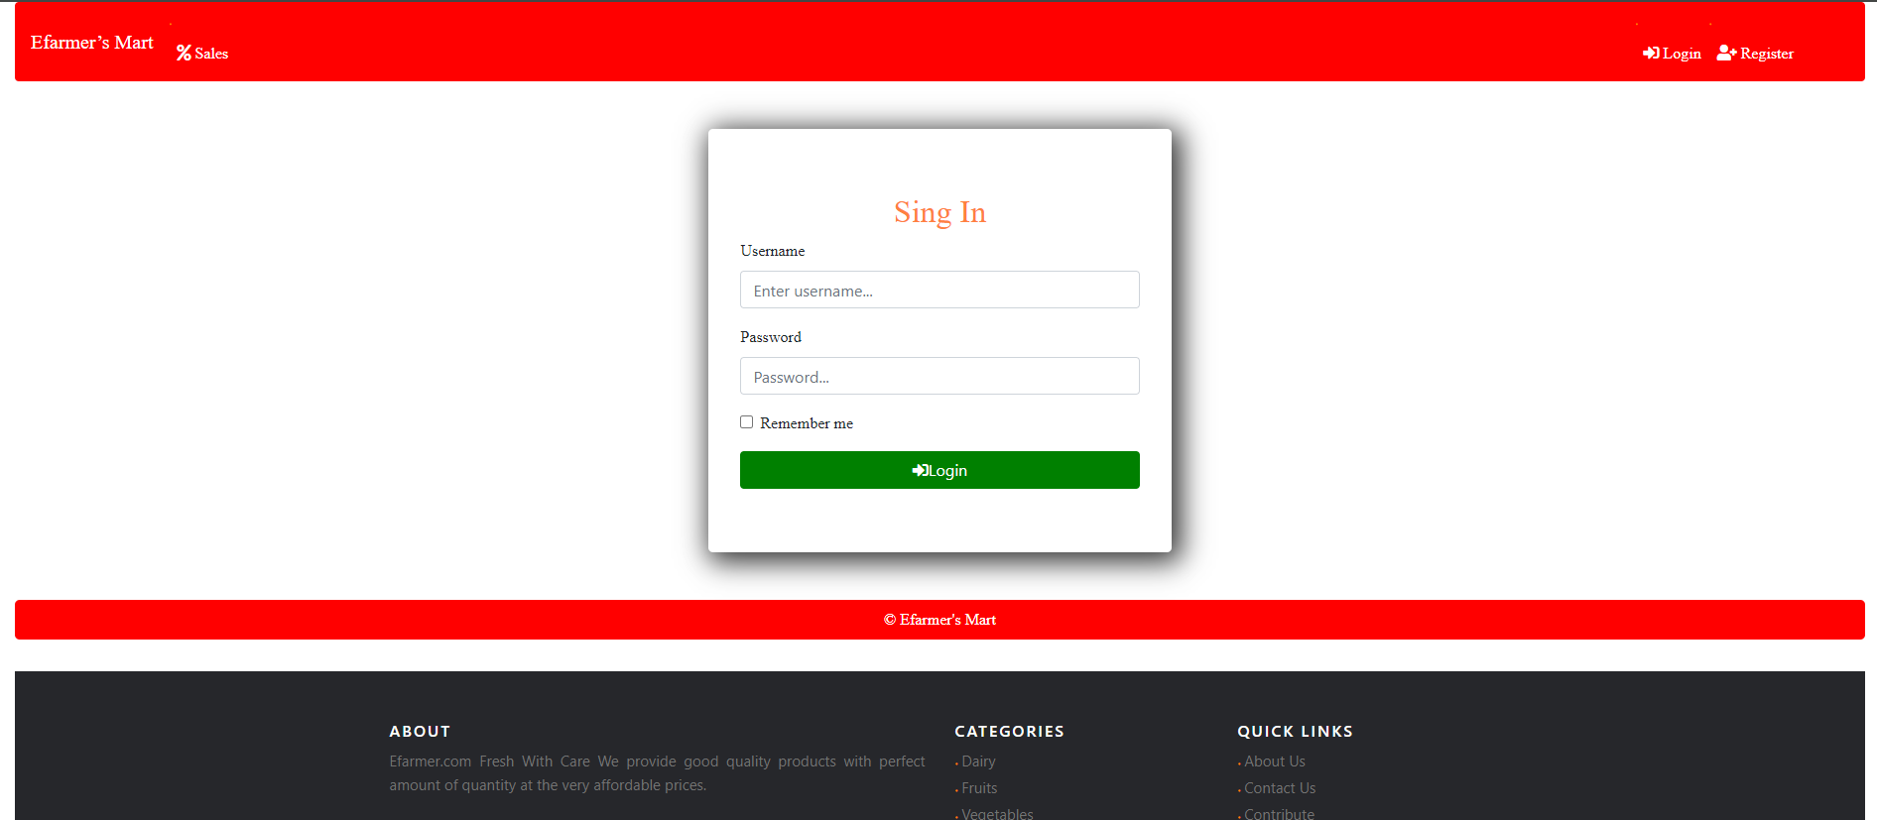

Figure 3: Sing In Page

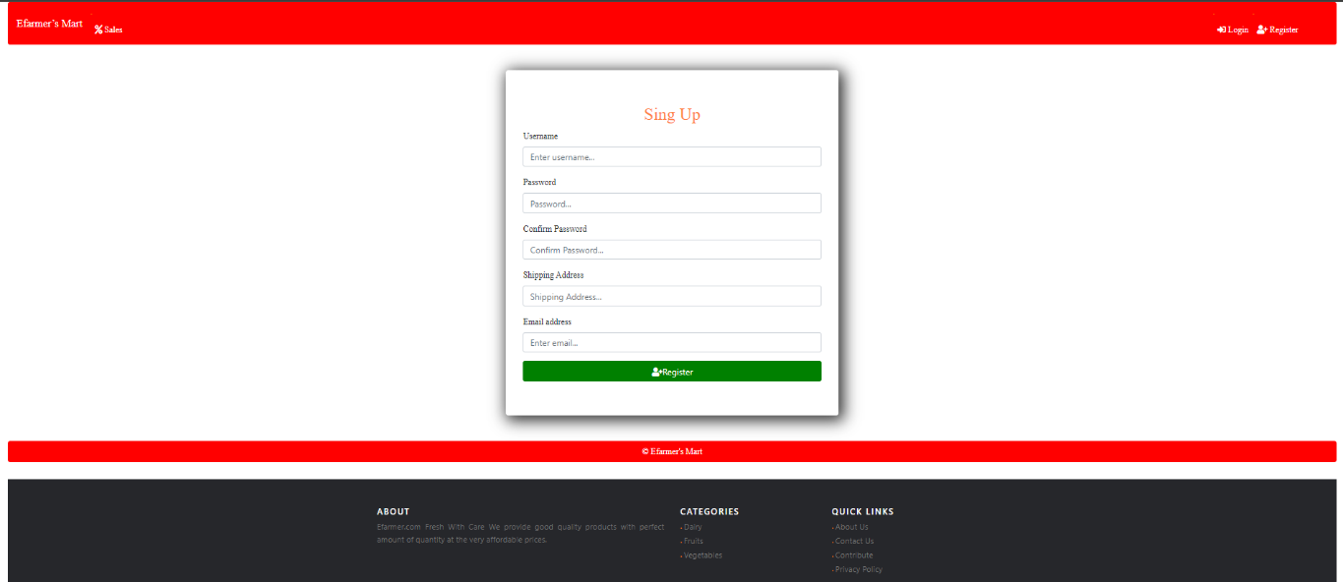

Figure 4: Sing Up Page

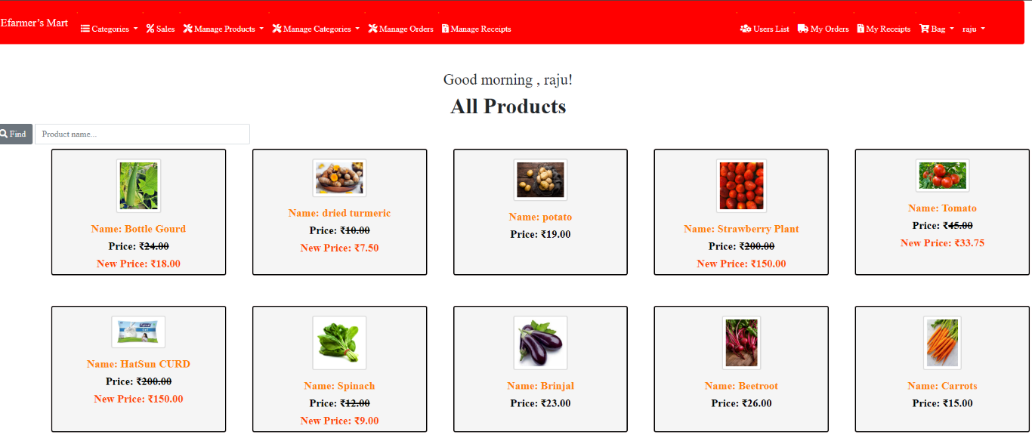

Figure 5: Farmers Home page

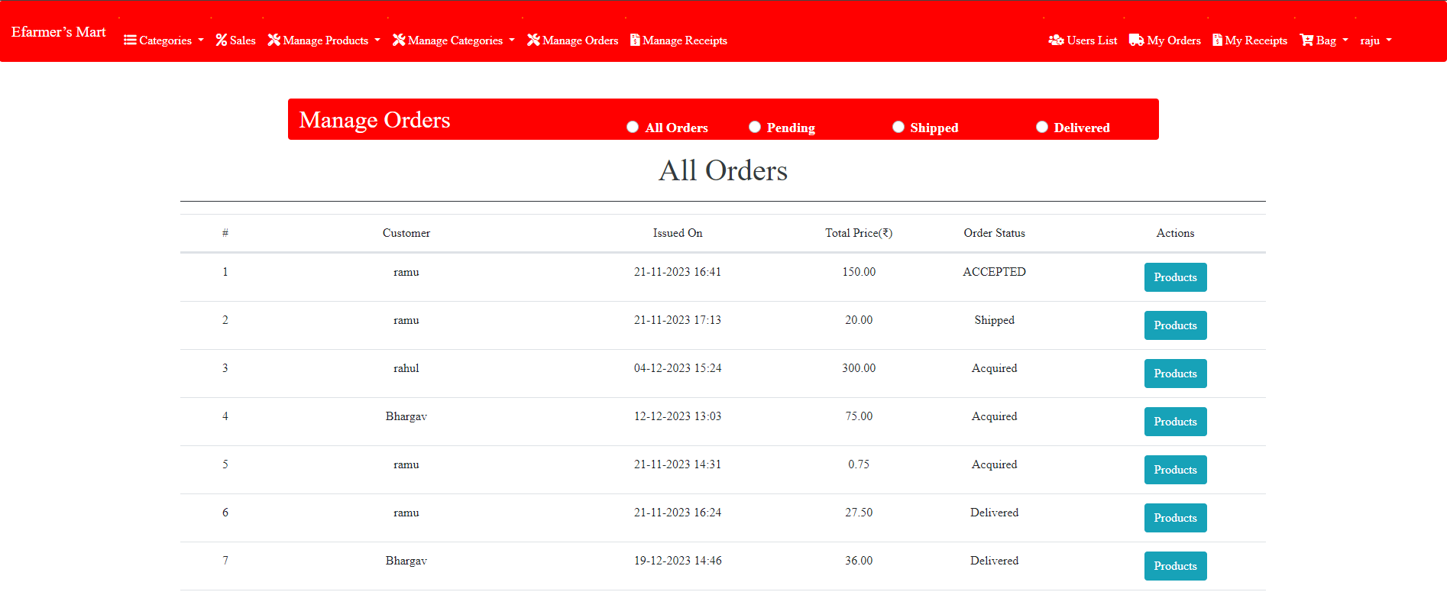

Figure 6: Farmers order page

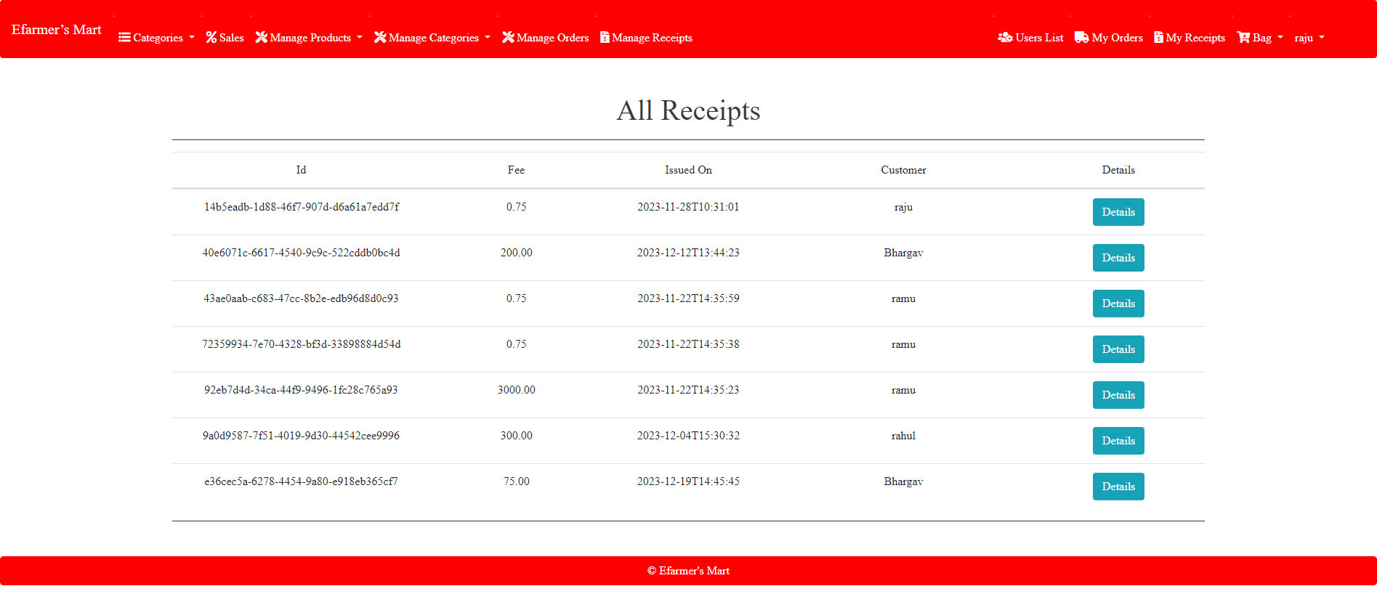

Figure 7: Farmers receipts page

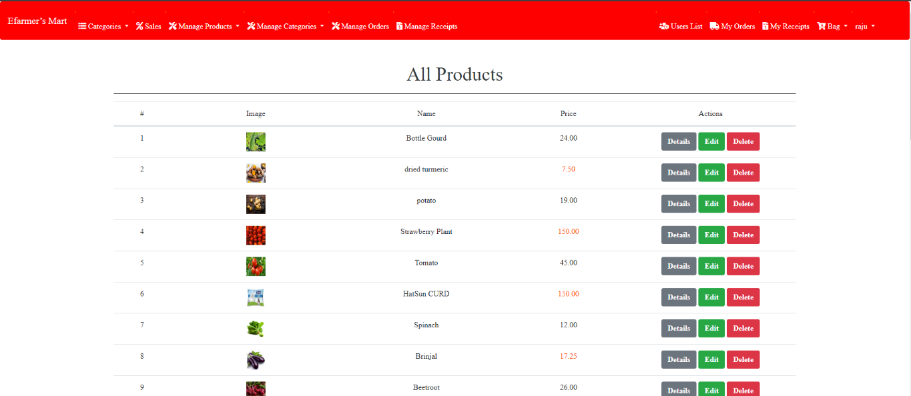

Figure 8: Farmers Product list

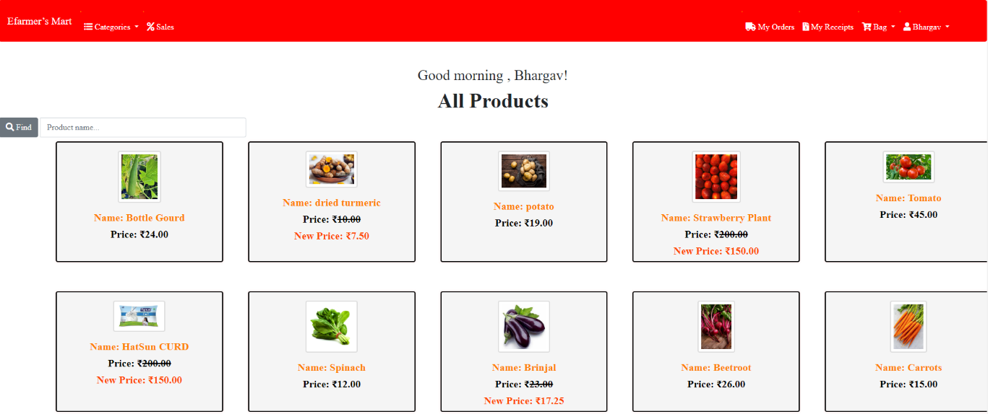

Figure 9: Users homepage

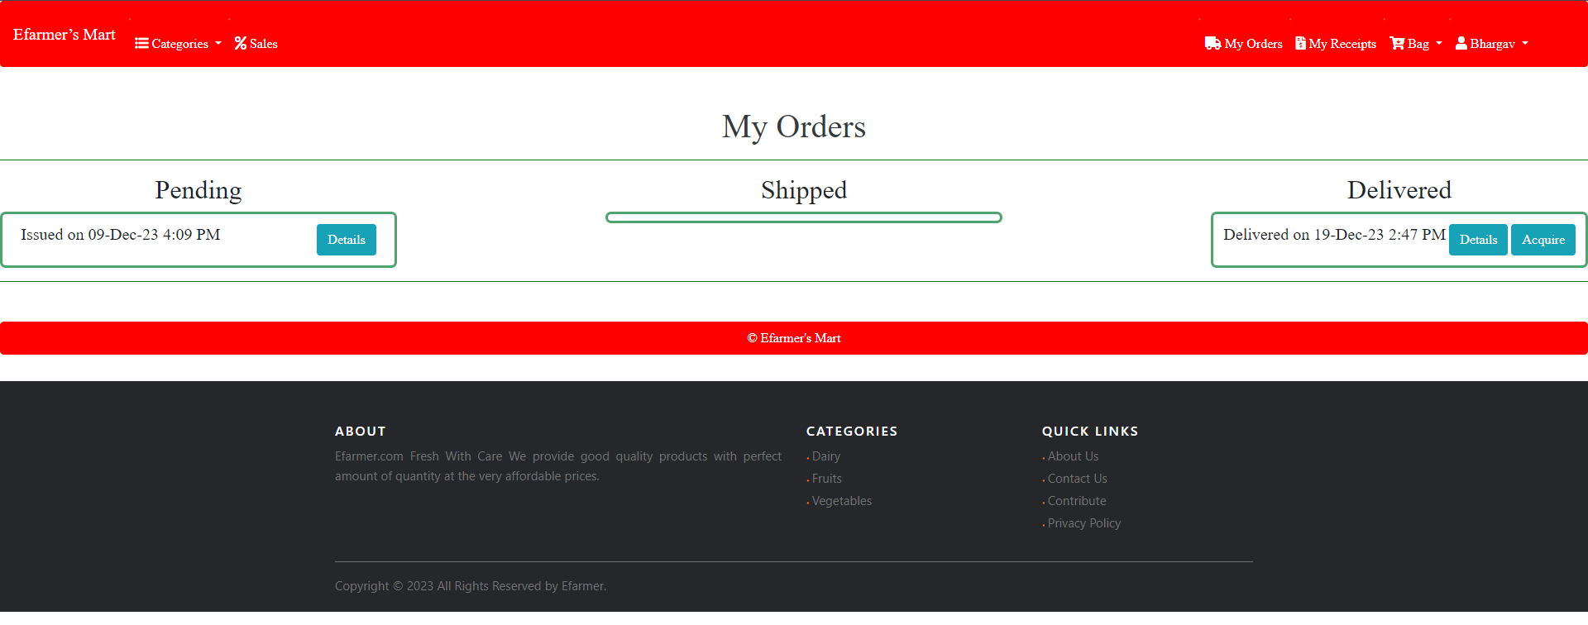

Figure 10: Users Order page

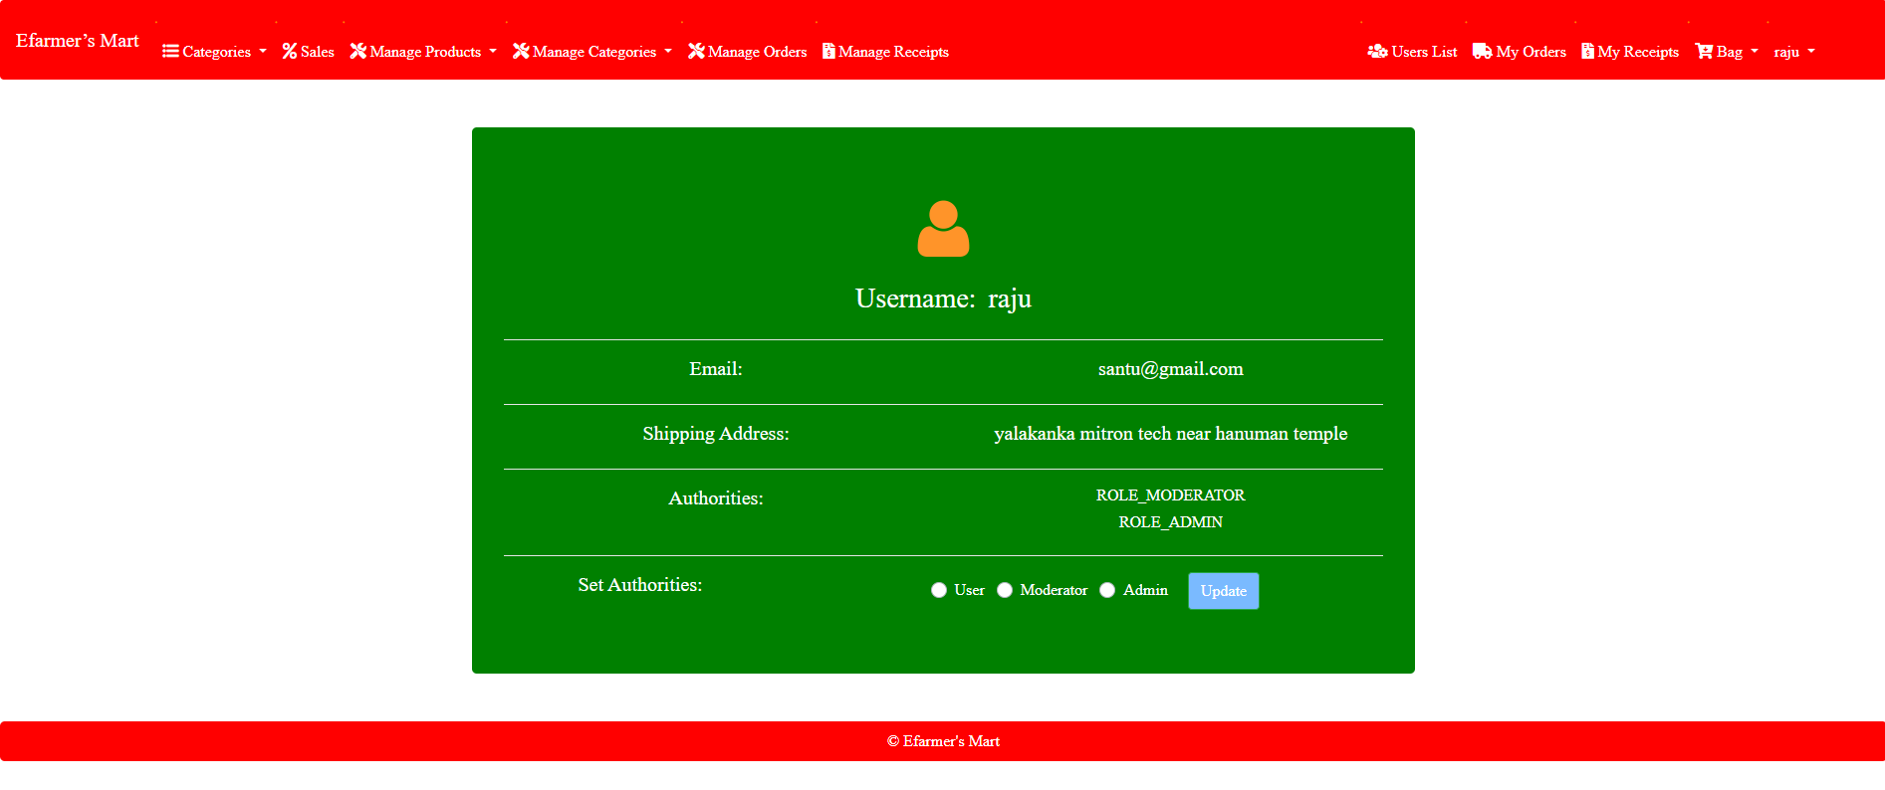

Figure 11: Admin page

**APPENDIX-C**

**ENCLOSURES**







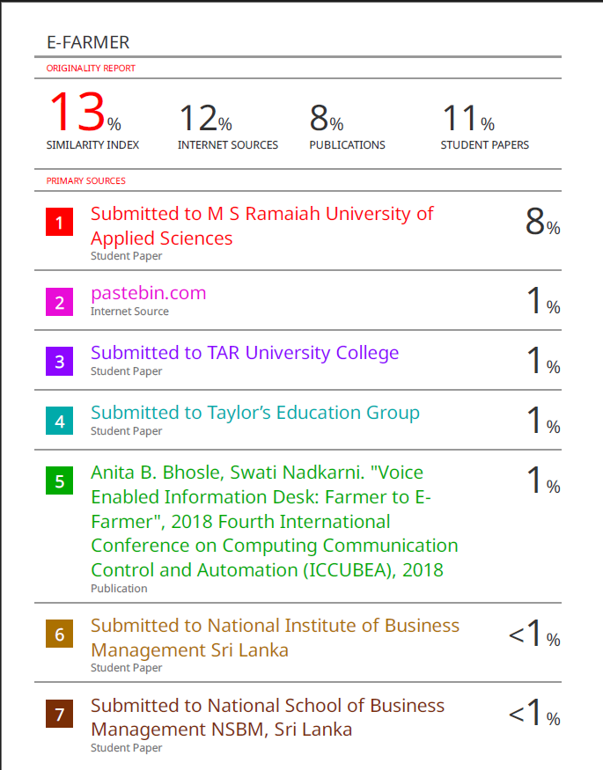

**Sustainable Development Goals**



Agroecological approaches such as Natural Farming, which are both cost-effective and environmentally friendly, would help to achieve the Sustainable Development Goals. They can provide improved income and financial stability by lowering input costs, which would help reduce poverty, bring about gender equality, and promote sustainable production and consumption habits. This strategy would assure food security and zero hunger by increasing yield, diversifying cropping, and providing year-round access to a variety of nutritious supplies and income-generating crops.